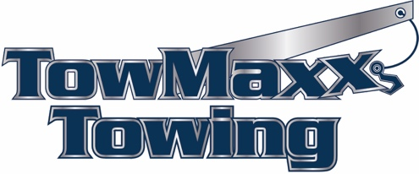

Vehicle Release Authorization Form
“For insurance release purposes only”
This letter shall serve as an authorization to release the vehicle described below to:

Name of Company, Representative, or Individual with Authorization to Take Possession of Vehicle:

Registered Owner Name:

Release to:

Address:

City, State, Zip Code:
Phone #:
Year, Make, Model: _
Vehicle Identification #:

License Plate #:

WE/I UNDERSTAND THAT BY AUTHORIZING THE RELEASE OF THIS VEHICLE AND ITS CONTENTS TO THE PARTY MENTIONED ABOVE/PARTIES, WE/I ALSO RELIEVE TOWMAXX TOWING FROM ANY AND ALL CLAIMS, ACTIONS, DEMANDS, RESPONSIBILITIES, AND DAMAGES THAT MAY ARISE AS A RESULT OF THIS SAID RELEASE OF THE VEHICLE AND ITS CONTENTS TO THE COMPANY MENTIONED ABOVE INDIVIDUAL.

PROPER DOCUMENTATION TO PROVE OWNERSHIP OF THIS VEHICLE SHALL BE ATTACHED TO THE VEHICLE FILE.

Registered Owner Signature: Release Date:

PLEASE FILL OUT THE COMPLETE FORM AND SEND IT TO: dispatch@towmaxxtowing.com

TowMaxx Towing Service LLC
3816 NW 49th ST
Tamarac, FL 33309
954-680-0105

